# Experimental Report

## CP1N7-24721015 李鹏麒

# **所属内容：Experimental N7-C1-20241223**

# **完成部分说明：编写算法与代码、调试与测试、撰写实验报告**

**The programme language**: C language

**The programming platform**: Visual Studio Code

* **Requirements Analysis - System Analyst**

The program must meet the following functional requirements:

1. Binary Search

A function that can search for a specific element in a sorted integer array and return its index. If not found, return -1.

1. Sorting

A function that can sort an integer array using the bubble sort algorithm.

1. String Processing

Count the occurrences and first appearance position of a given character in a string. Read a string from standard input. Print the string in three different formats.

1. Student Grade Management

Allow users to enter students' grades. Calculate each student's average score, highest score, and lowest score. Print statistical information of each student's grades.

1. Main Menu

Provide a user interface that allows users to select different program functions.

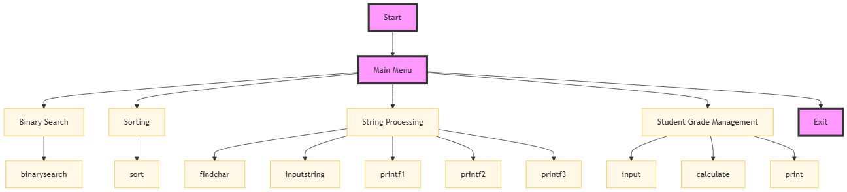

* **Outline Design (System Design) - Developers**

**Functional Description：**

1. Main Menu:

Displays options to the user and captures the chosen option.

Coordinates the flow of control to other modules based on user input.

1. Binary Search:

Accepts a sorted array and a target value from the user.

Performs a binary search to find the target value and returns its index or a not-found indicator.

1. Sort Array:

Accepts an unsorted array from the user. Sorts the array using the bubble sort algorithm and stores the result in a data store.

1. Process Strings:

Accepts a string and performs various operations such as finding character occurrences, inputting strings, and printing strings in different formats.

1. Manage Student Grades:

Allows input of student scores, calculates statistics, and prints the results.

**Data Structure Description:**

1. User Input Buffer:

Temporary storage for user inputs before processing.

Structure: Array of characters or strings.

1. Sorted Array:

Stores the result of the sorting process.

Structure: Array of integers.

1. String Data:

Holds the input strings and processed results.

Structure: Character array.

1. Student Records:

Stores student scores and calculated statistics.

Structure: Array of structures, where each structure contains scores, average, high, and low scores.

**Data Flow Diagram (DFD)**

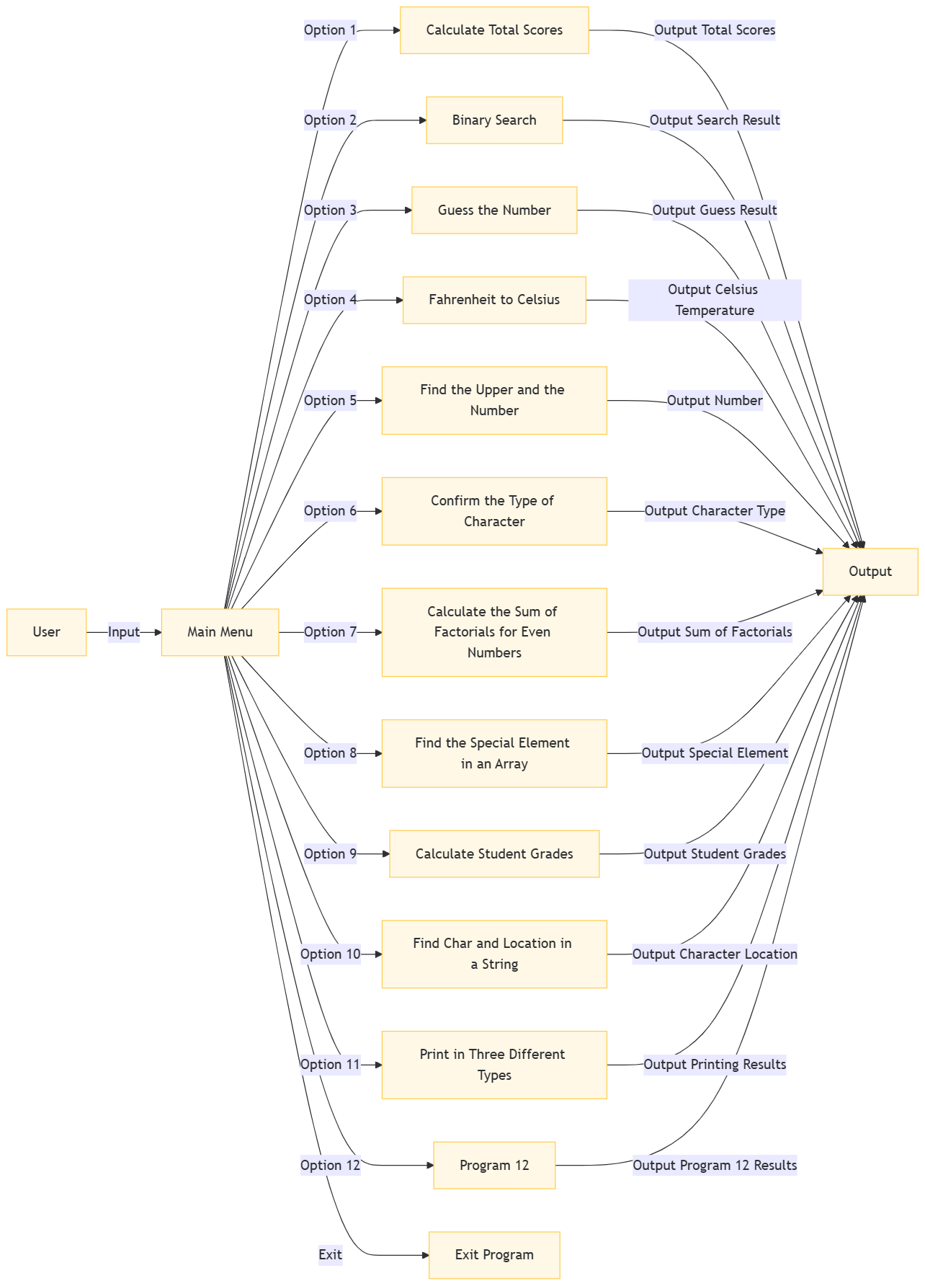

### **Functional Module Structure Diagram**



* **Detailed design**

The entire:

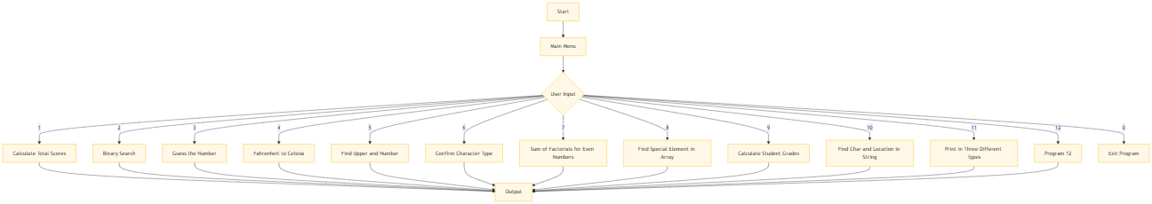

Program 1:

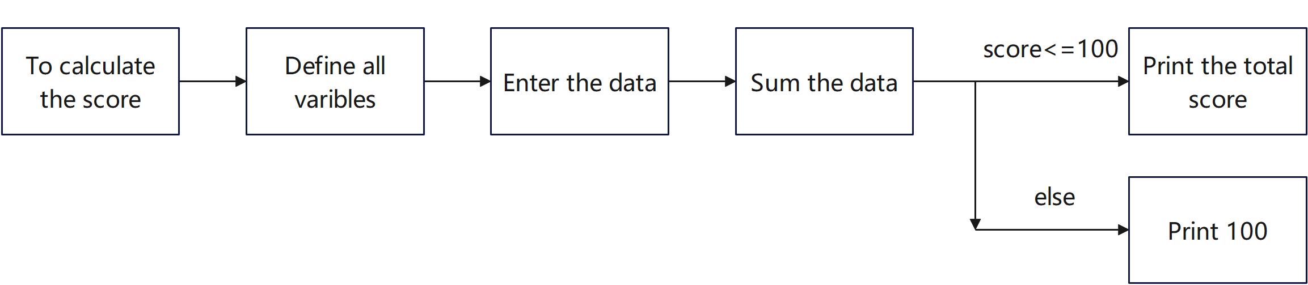

Program 2:

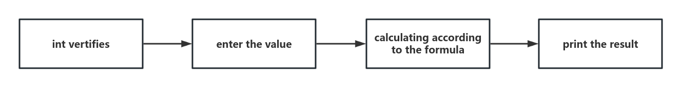

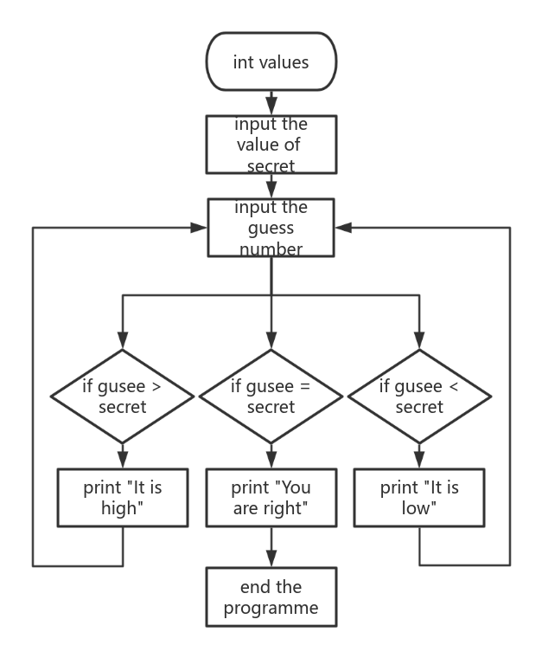Program 3:

Program 4:

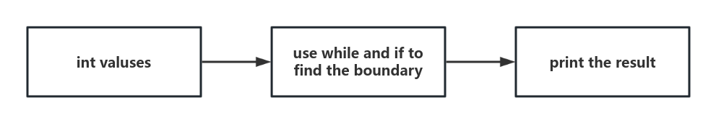

Program 5:

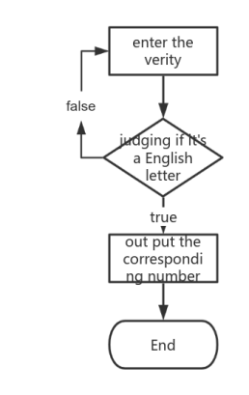

Program 6:

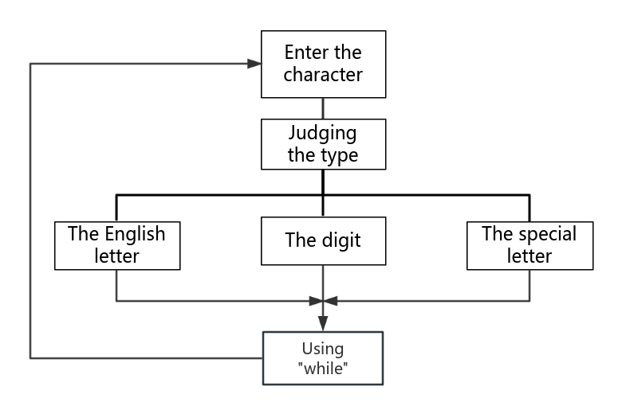

Program 7:

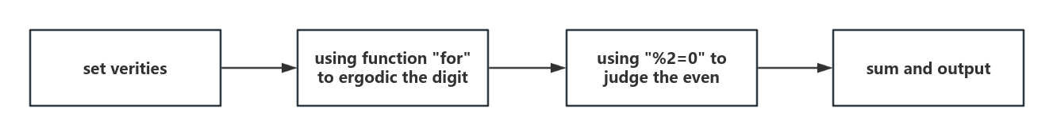

Program 8:

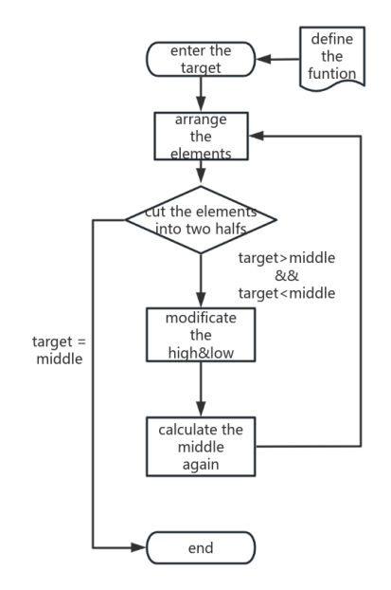

Program 9:

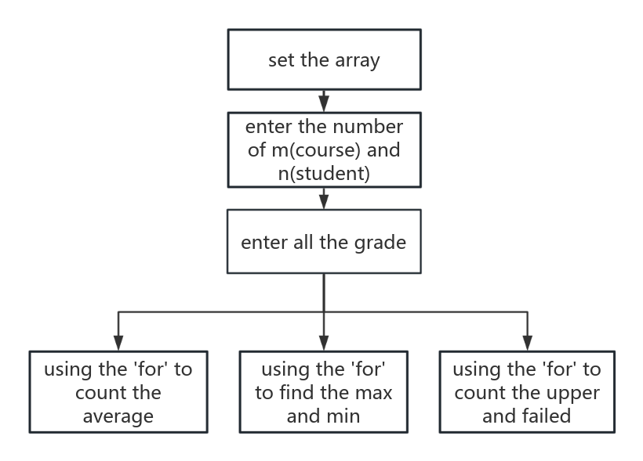

Program 10:

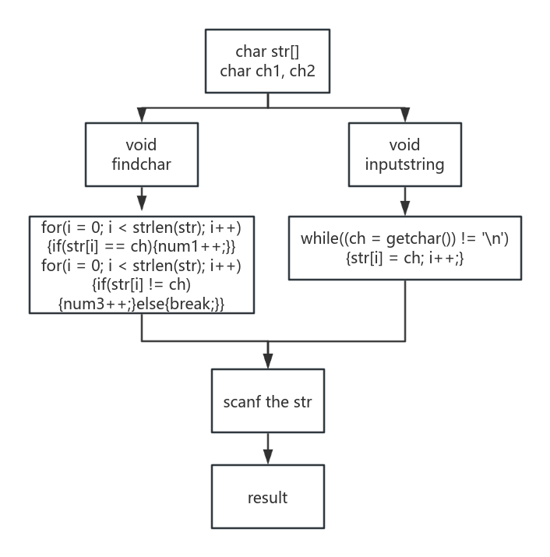

Program 11:

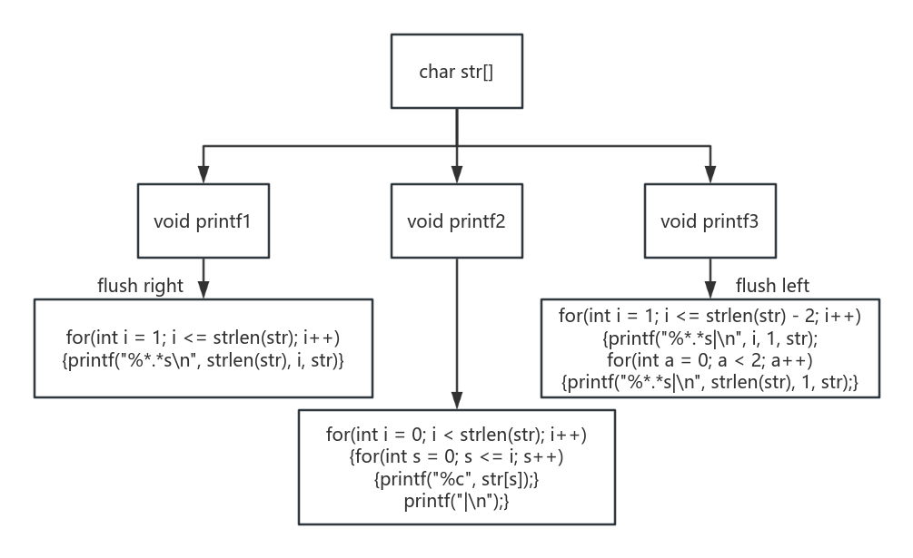

Program 12:

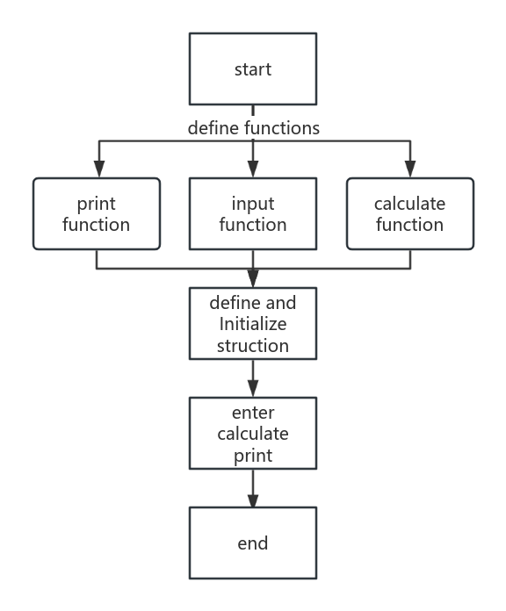

* **Testing**

